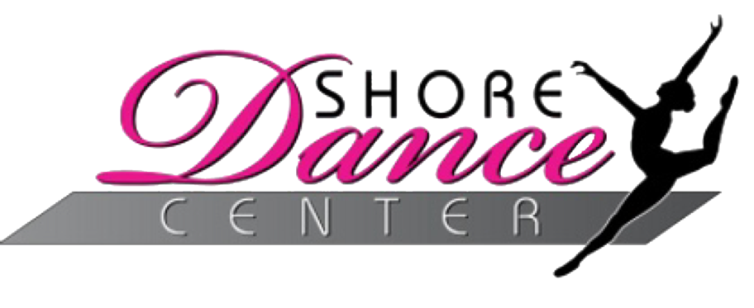

Shore Dance Center
Class Shoes and Attire

Tiny Tots
- Leotard (any color)
- Tights
- Pink Ballet Slippers

Preschool Ballet –
- Leotard (any color)
- Tights
- Pink Ballet Slippers

4-5 y/o Tap/Ballet
- Leotard (any color)
- Tights
- Pink Ballet Slippers
- Black Tap Shoes (Mary Jane style)

5-6 Year Old Classes
- Tap/Ballet
  - Leotard (any color)
  - Tights
  - Pink Ballet Slippers
  - Black Tap Shoes (Mary Jane style)
- Jazz/Hip Hop
  - Leotard (any color) and Tights (or Fitted Top and Leggings),
  - Tan Jazz Shoes
  - Any Clean Athletic Sneaker (recital sneakers will be ordered in January)

7-9 Year Old Classes
- Triple Combo Class
  - Leotard (any color)
  - Tights
  - Pink Ballet Slippers
  - Black Tap Shoes (Mary Jane style)
  - Tan Jazz Shoes
- Musical Theater
  - Leotard (any color) and Tights (or Fitted Top and Leggings)
  - Tan Jazz Shoes

Level 1 Classes
- Tap/Ballet
  - Leotard (any color)
  - Tights
  - Pink Ballet Slippers
  - Black Tap Shoes (Mary Jane style)
- Jazz/Hip Hop
  - Leotard (any color) and tights (or Fitted Top and Leggings)
  - Tan Jazz Shoes
  - Any Clean Athletic Sneaker (recital sneakers will be ordered in January)

*More classes on the next page*

Level 2 + Up Classes
- Ballet
  - Black Leotard
  - Tights (Tan or Pink)
  - Pink Ballet Slippers
- Tap
  - Leotard (any color) and Tights (any color) or Fitted Top and Leggings
  - Black Lace-Up Flat Tap Shoes
- Jazz
  - Leotard (any color) and Tights (any color) or Fitted Top and Leggings
  - Tan Jazz Shoes
- Lyrical
  - Leotard (any color) and Tights
  - Split-Sole Lyrical Slipper (Capezio Pirouette Shoes)
- Contemporary
  - Leotard (any color) and Tights
  - Foot Undeez (Capezio Foot Undeez)
- Hip Hop
  - Fitted Top and Leggings
  - Any clean athletic sneaker (recital sneakers will be decided in January)

Acrobatics
- Leotard
- No Shoes

